# EC2 Savings Plan

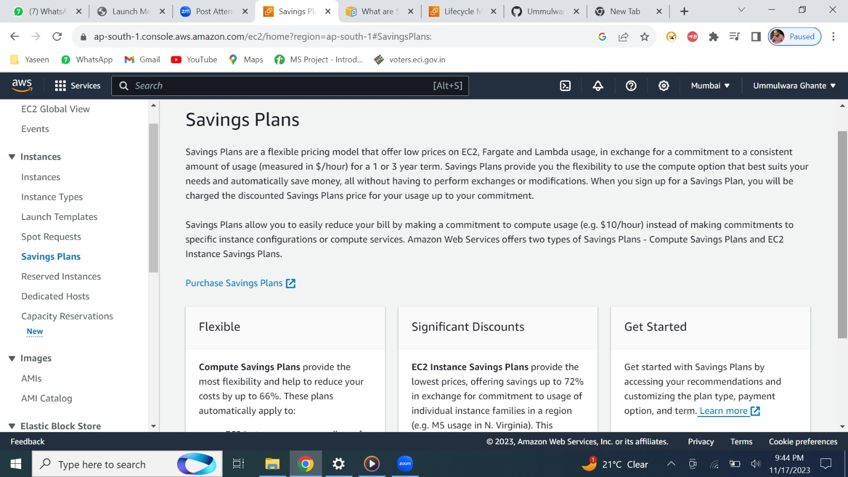

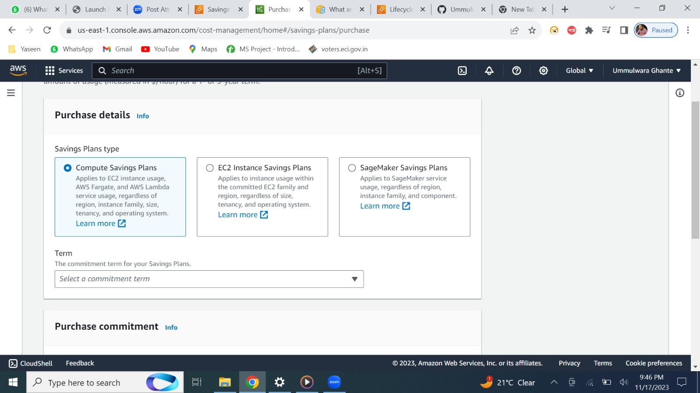

1. ***Compute***

In terms we have 1/3 years

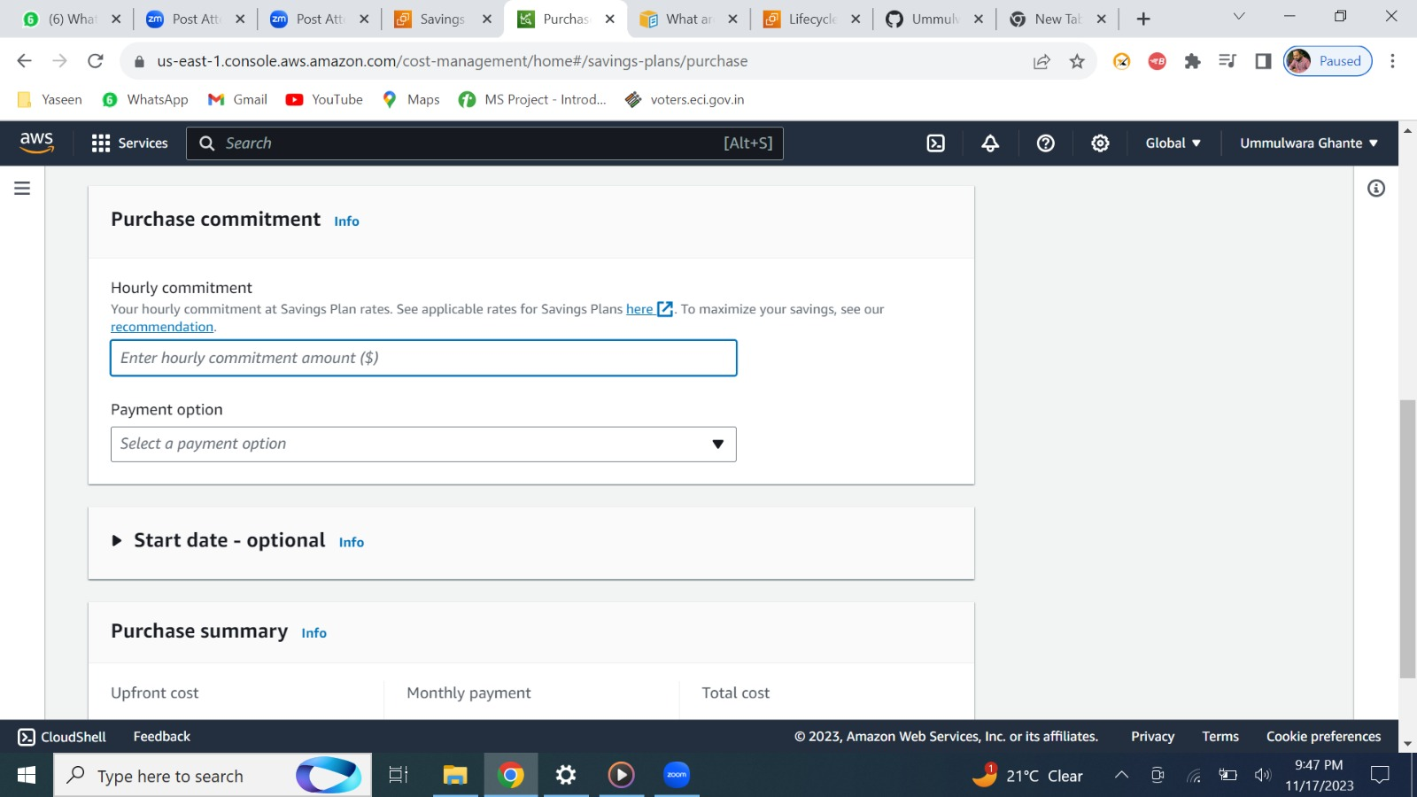

hourly you can set your price ex: 10$ if it extends more than 10 then you need to pay extra amount as on demand charge

payment can be done in 3 options

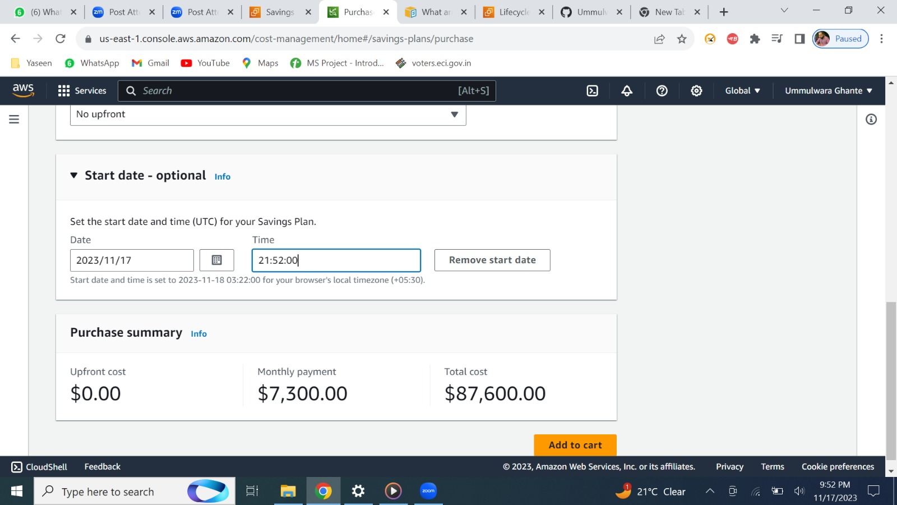

we can set the date and time, lastly, we can get all total amount.

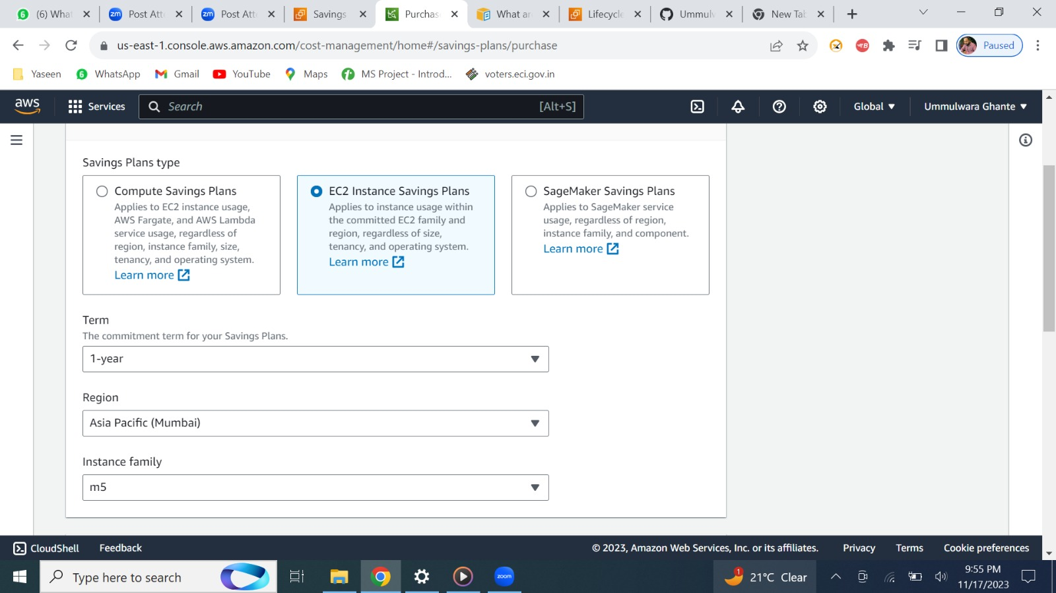

here we can set the term ,region, instance family as it is specific

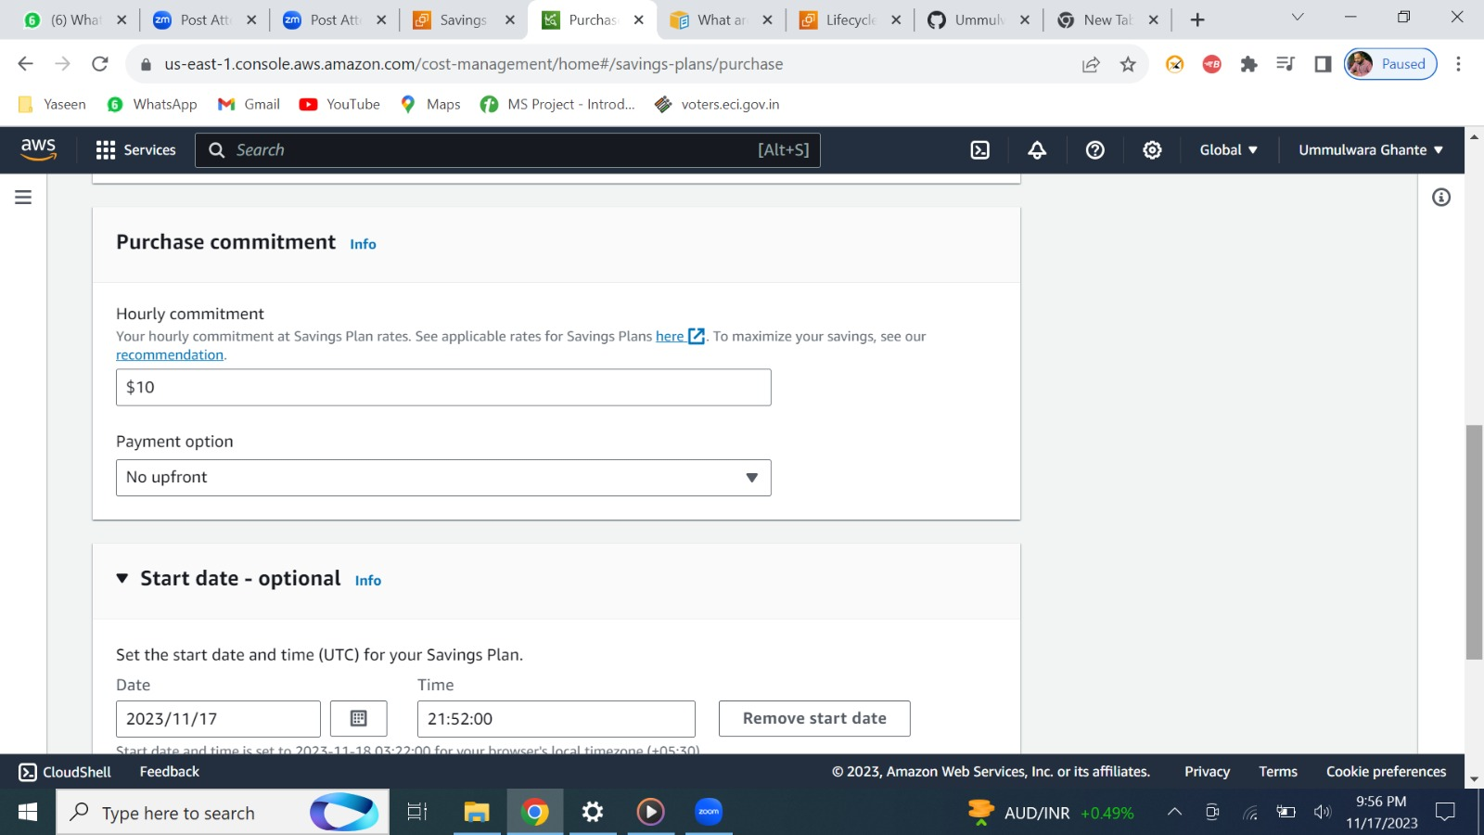

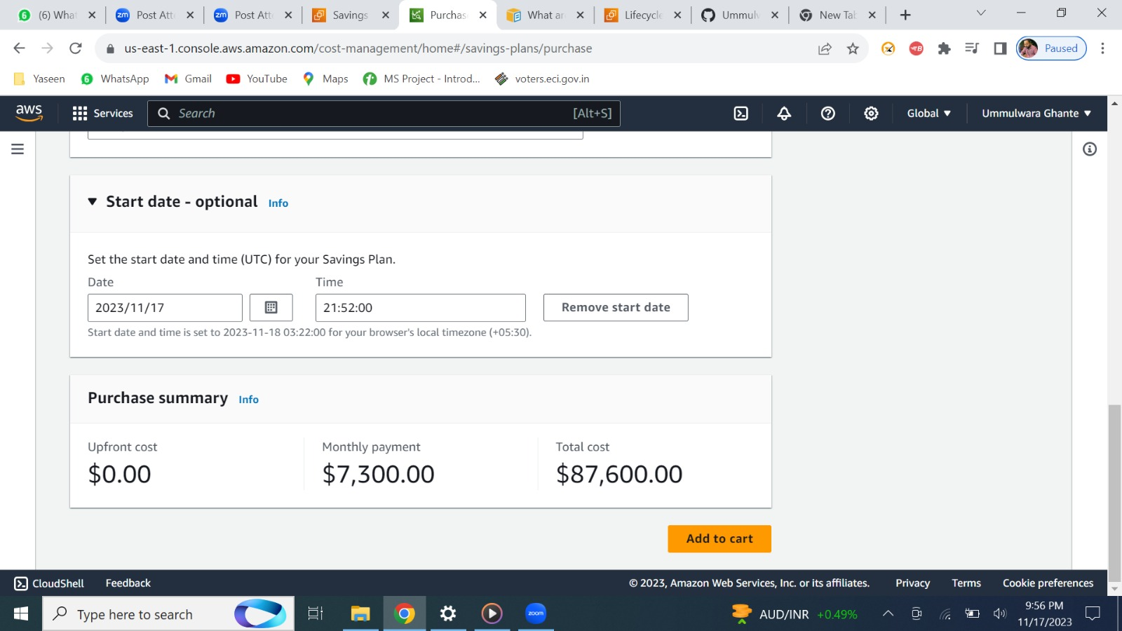

rest all is same

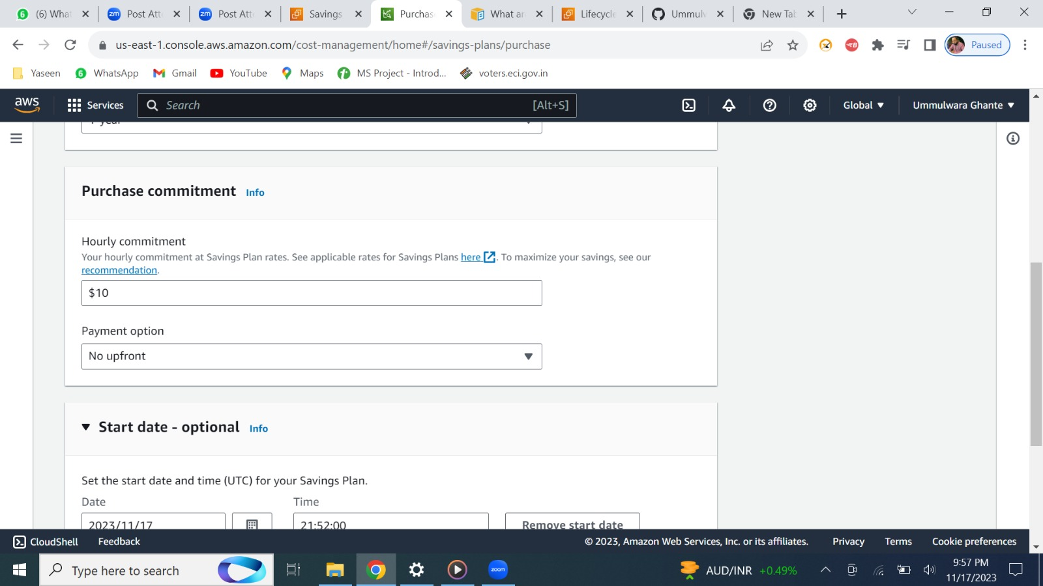

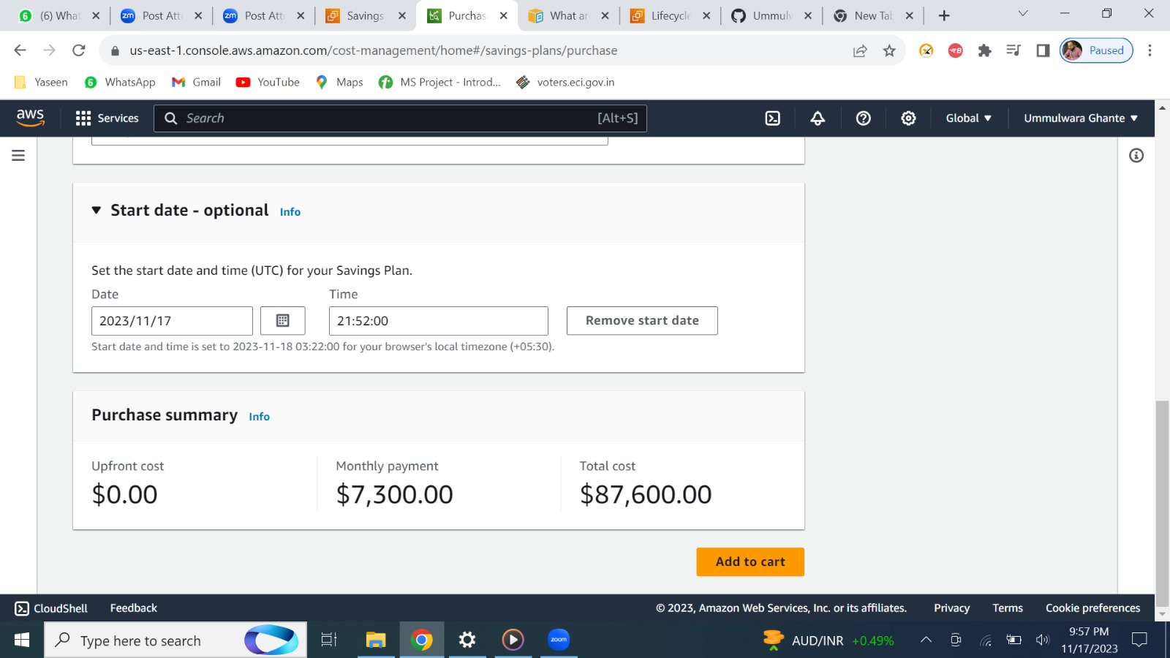



By clicking on learn more you can dive it in more about plans.